**User Manual For**

**Blood Donor:**

1. All new Donors can enter into our website with their basic details like (Name, Email, Phone, Address, Age, Password etc) through this signup page.

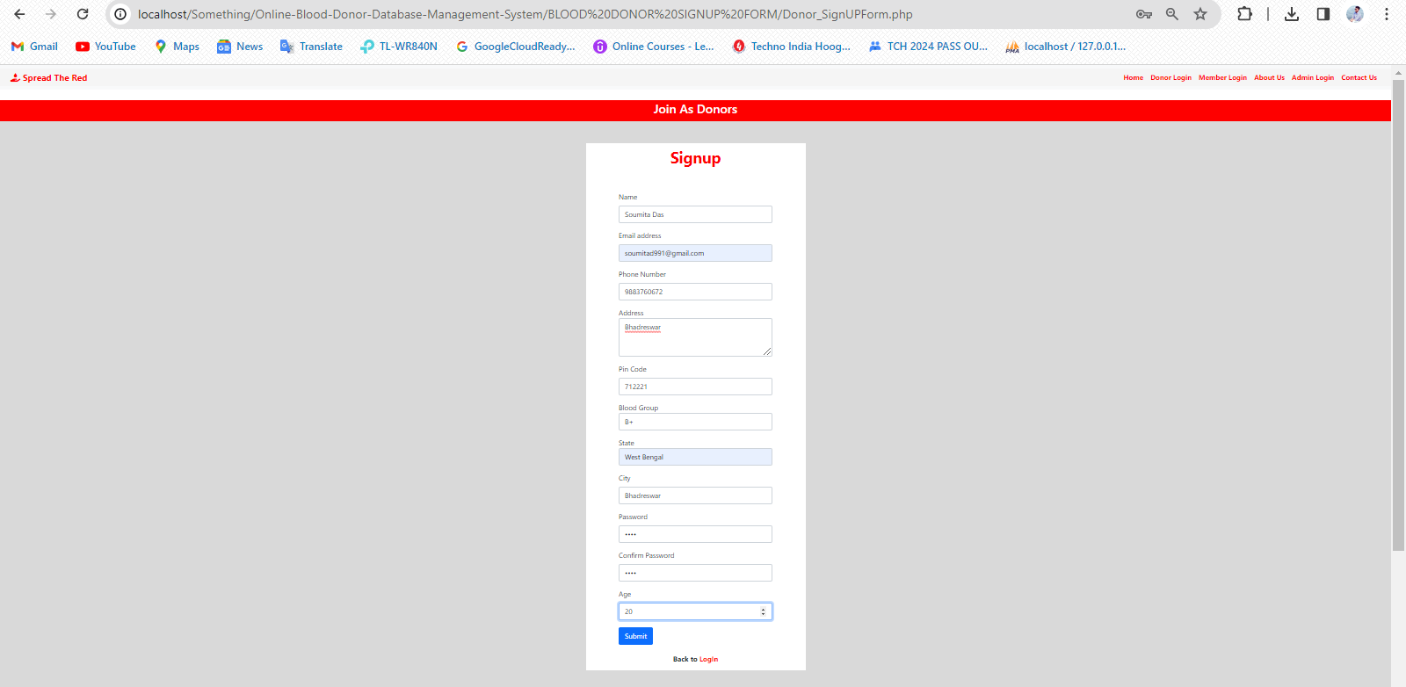

1. After submitting the sign up form, a random 6 digit otp will be sent to the donor’s specified email address.

The donor should put the otp correctly into the otp modal for completing the sign up process.

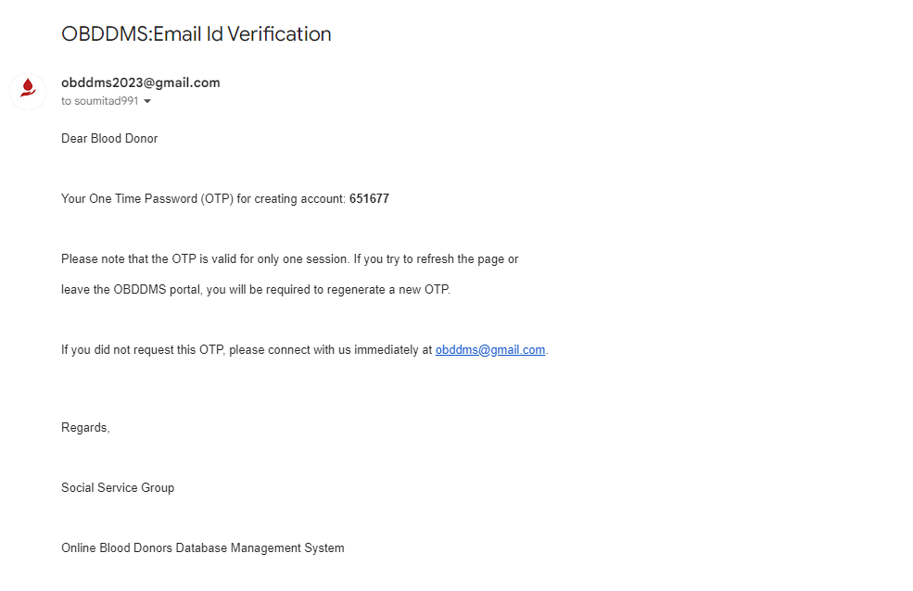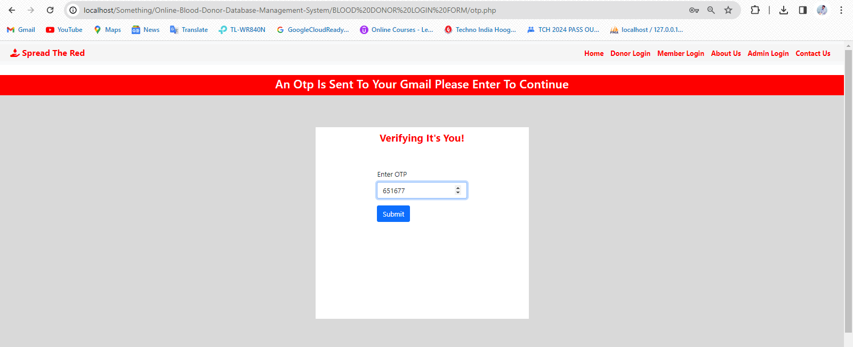

1. If the entered OTP is invalid, an error message will be displayed and donor should enter the correct otp again.

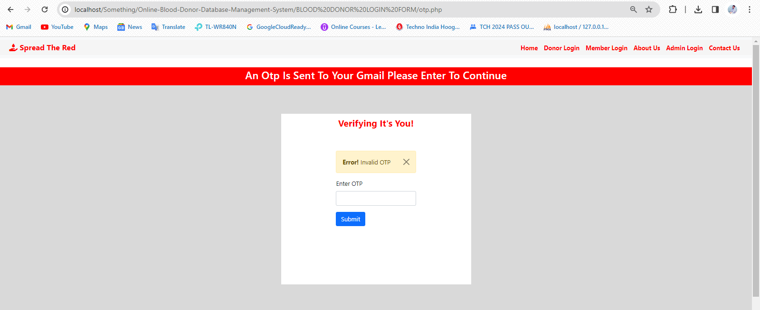

1. Donors will be redirected to the login page after completing the signup process. Where they can put their email address, and password.

If the credentials do not match, an error message will be displayed.

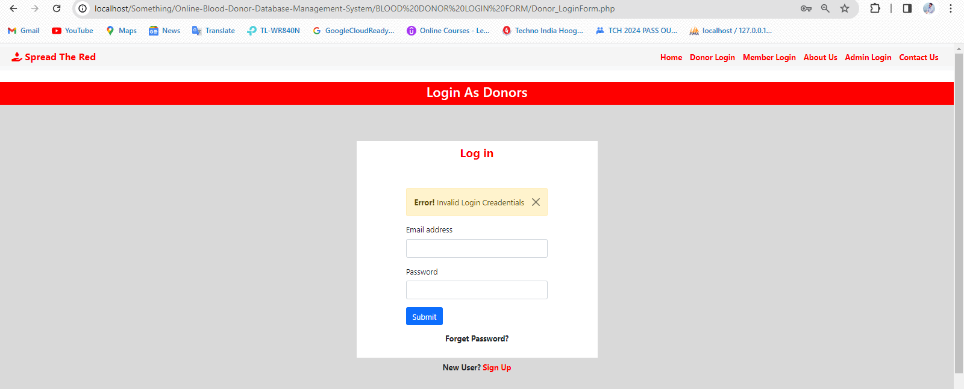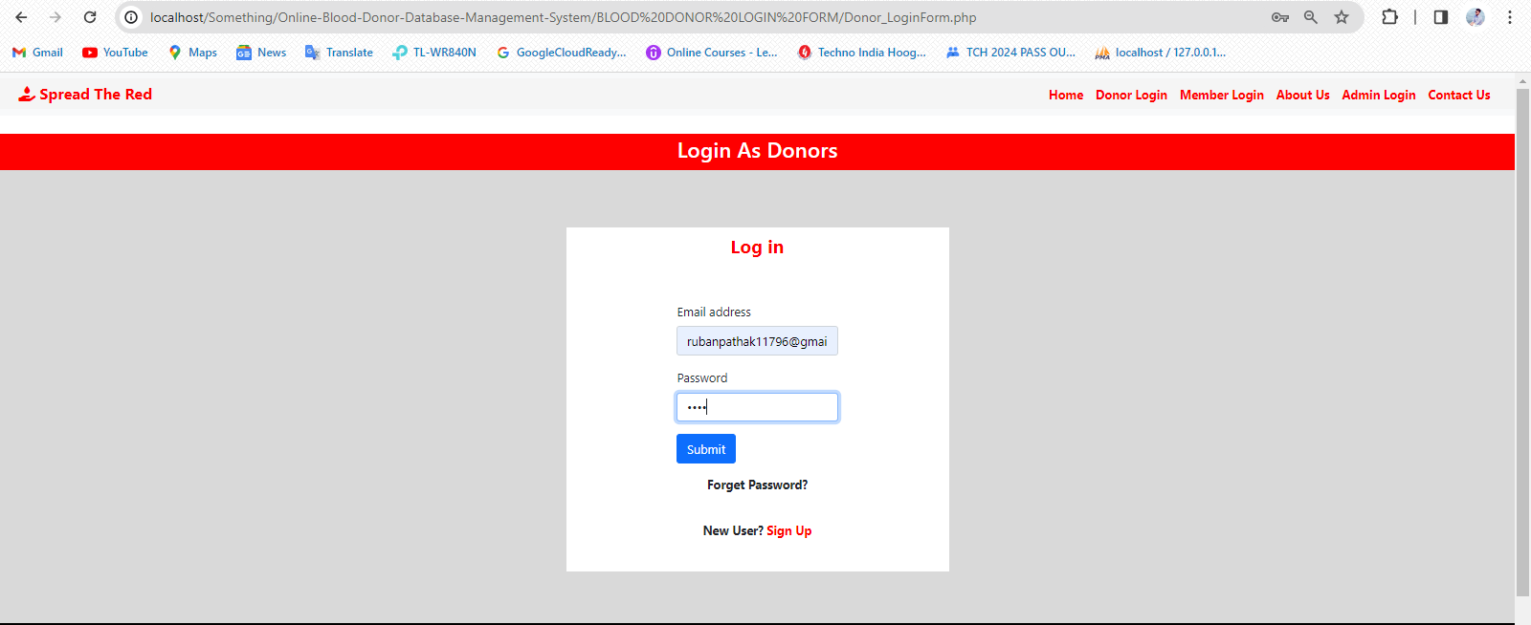

1. Otherwise the login process is complete and the donor will be redirected to the Dashboard.

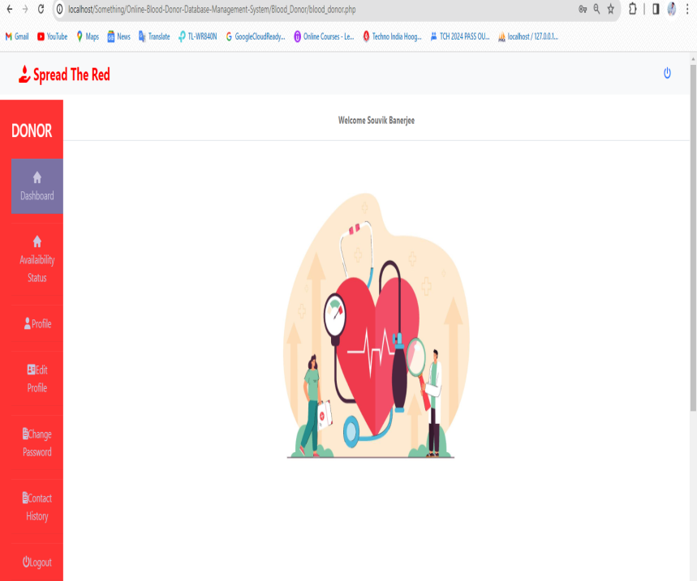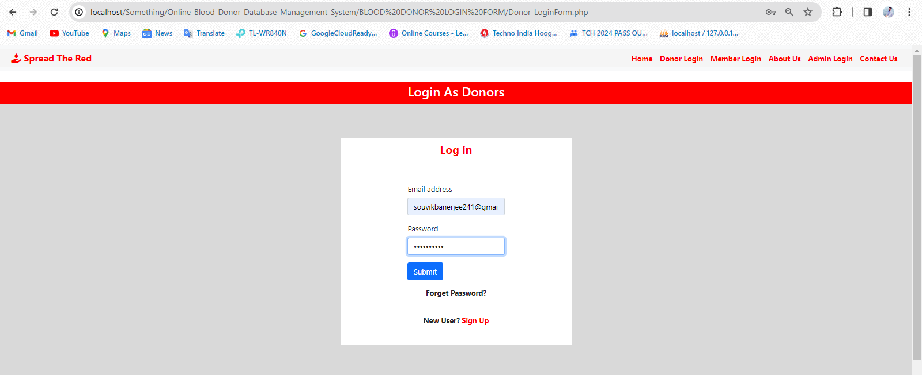

1. In the Availability Status section donors can hide their or show their profile from the other requesters after donating blood.

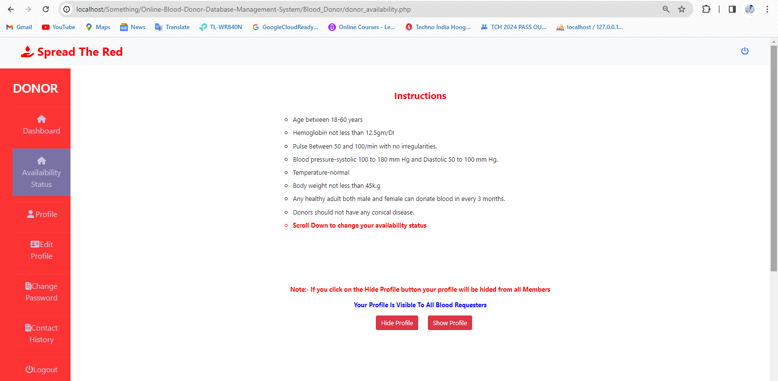

CLICK HERE TO SHOW YOUR PROFILE

CLICK HERE TO HIDE YOUR PROFILE

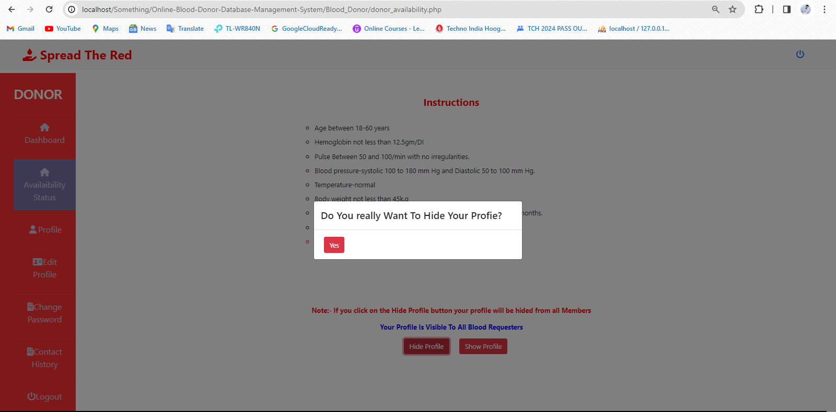

CLICK HERE TO CONFIRMATION FOR HIDE

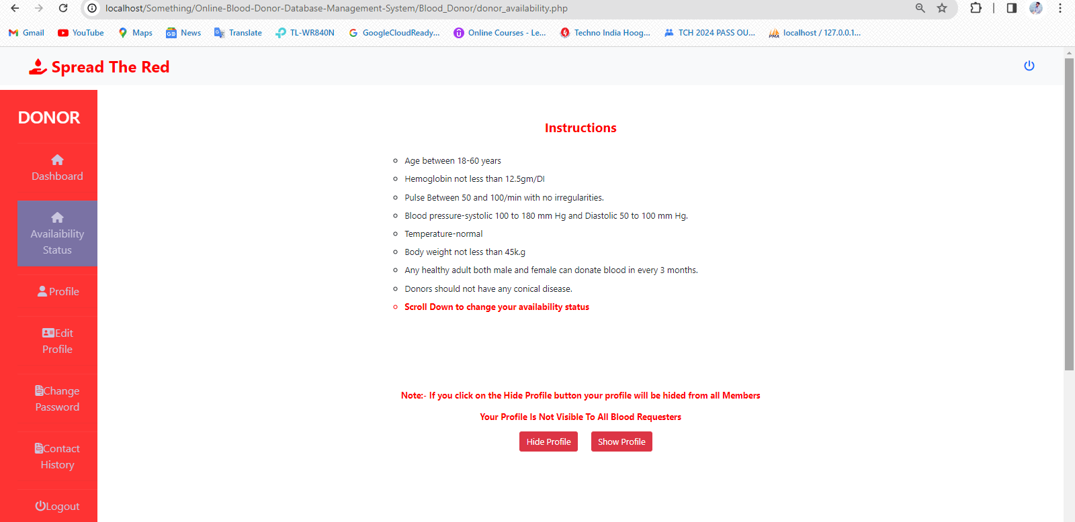

FINALLY YOUR PROFILE WILL BE HIDDEN

1. Now, in the contact history section the donor can accept reject or report that particular requester the process are here:-

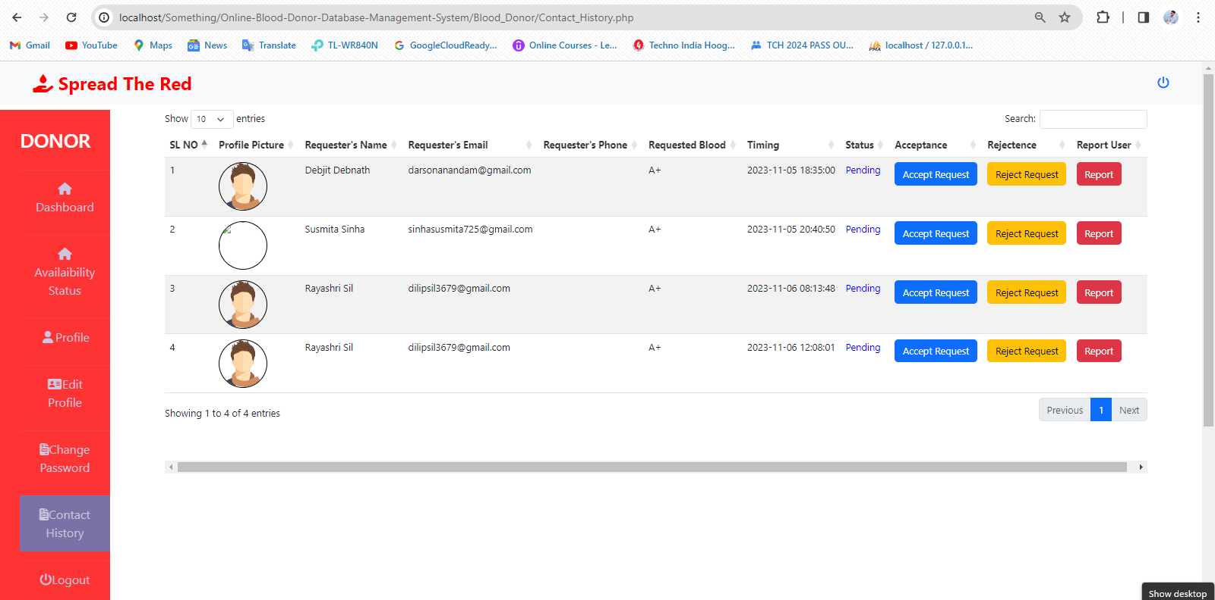

FIRSTLY, SELECT THIS FROM ANY OF THIS PENDING REQUEST (IF YOU WANT TO ACCEPT THIS REQUEST)

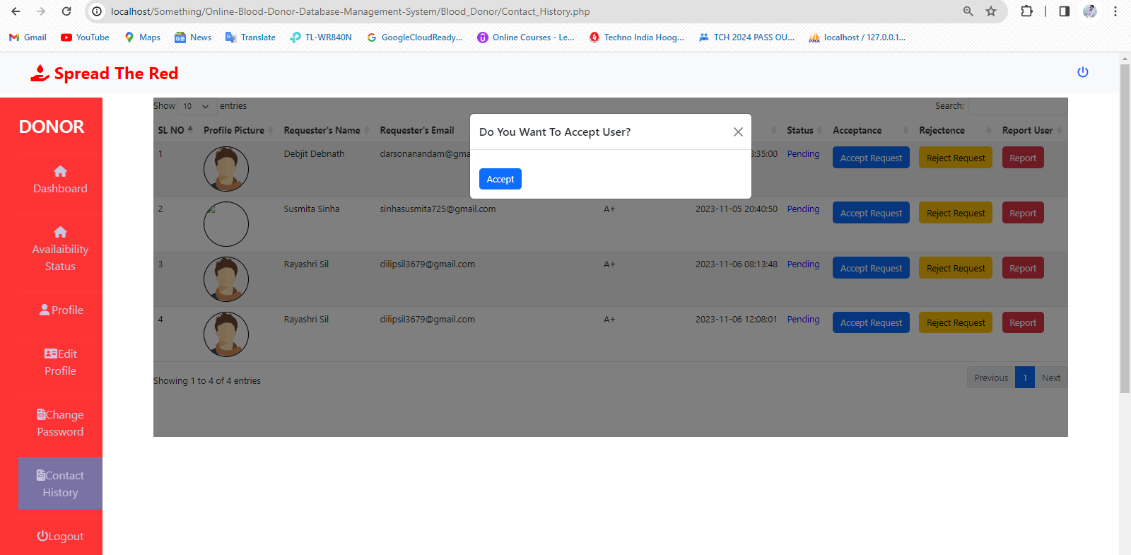

NOW ACCEPT THIS AND WAIT FOR SOME SECONDS BECAUSE AN EMAIL IS SENDING

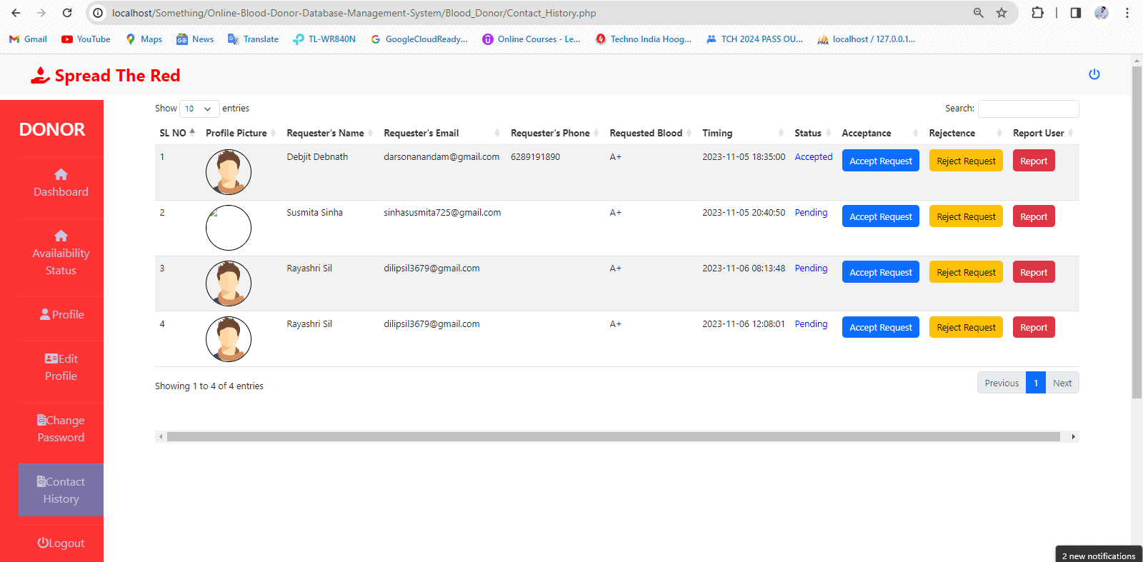

ALSO THE STATUS CAN BE CHANGED TO ACCEPTED

THE REQUESTER’S PHONE CAN BE SHOWN

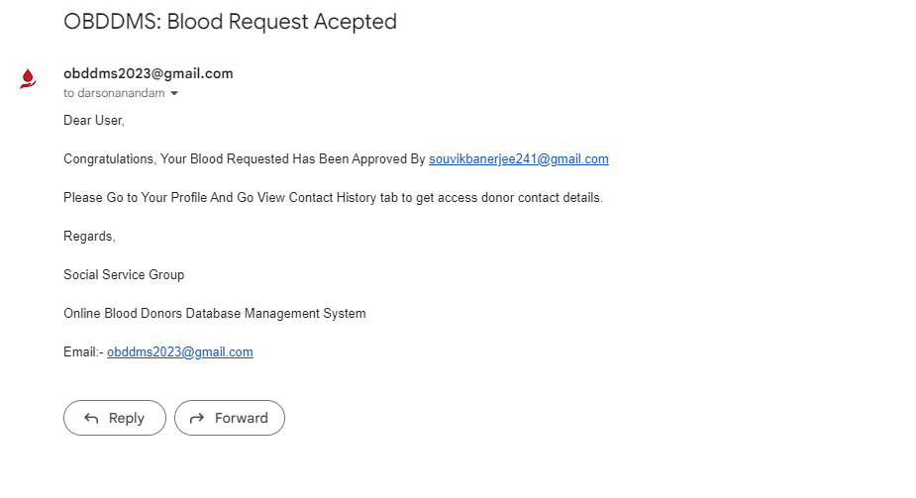

AT THAT TIME THIS EMAIL CAN BE SENT



IF YOU WANT TO REJECT THIS REQUEST CLICK ON THIS

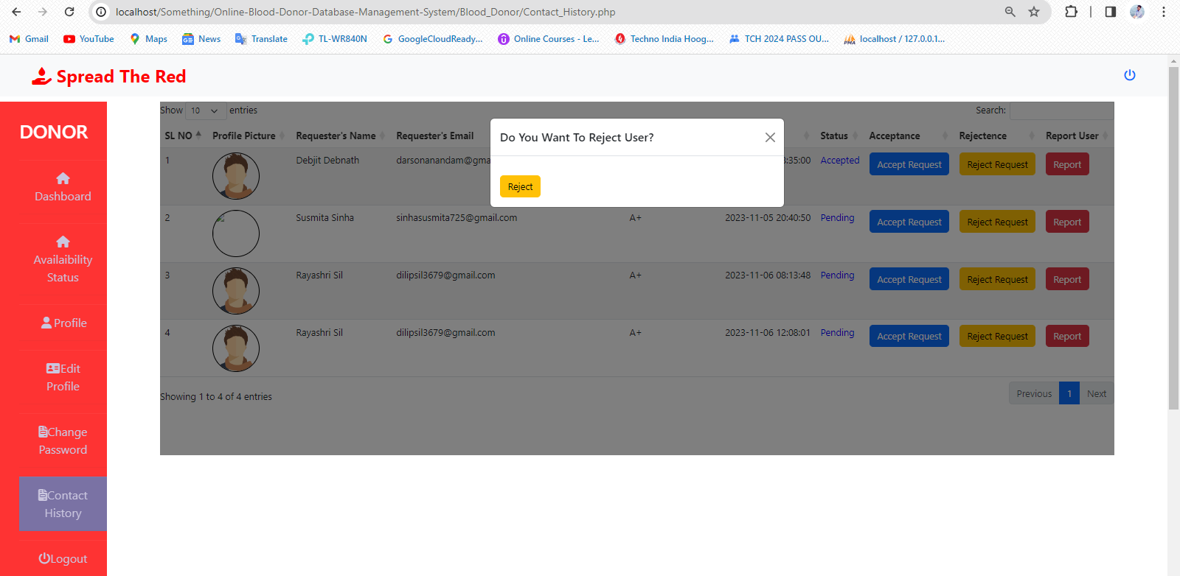

NEXT CLICK ON THIS TO REJECT REQUEST AND WAIT FOR SOME SECOND FOR SENDING EMAIL

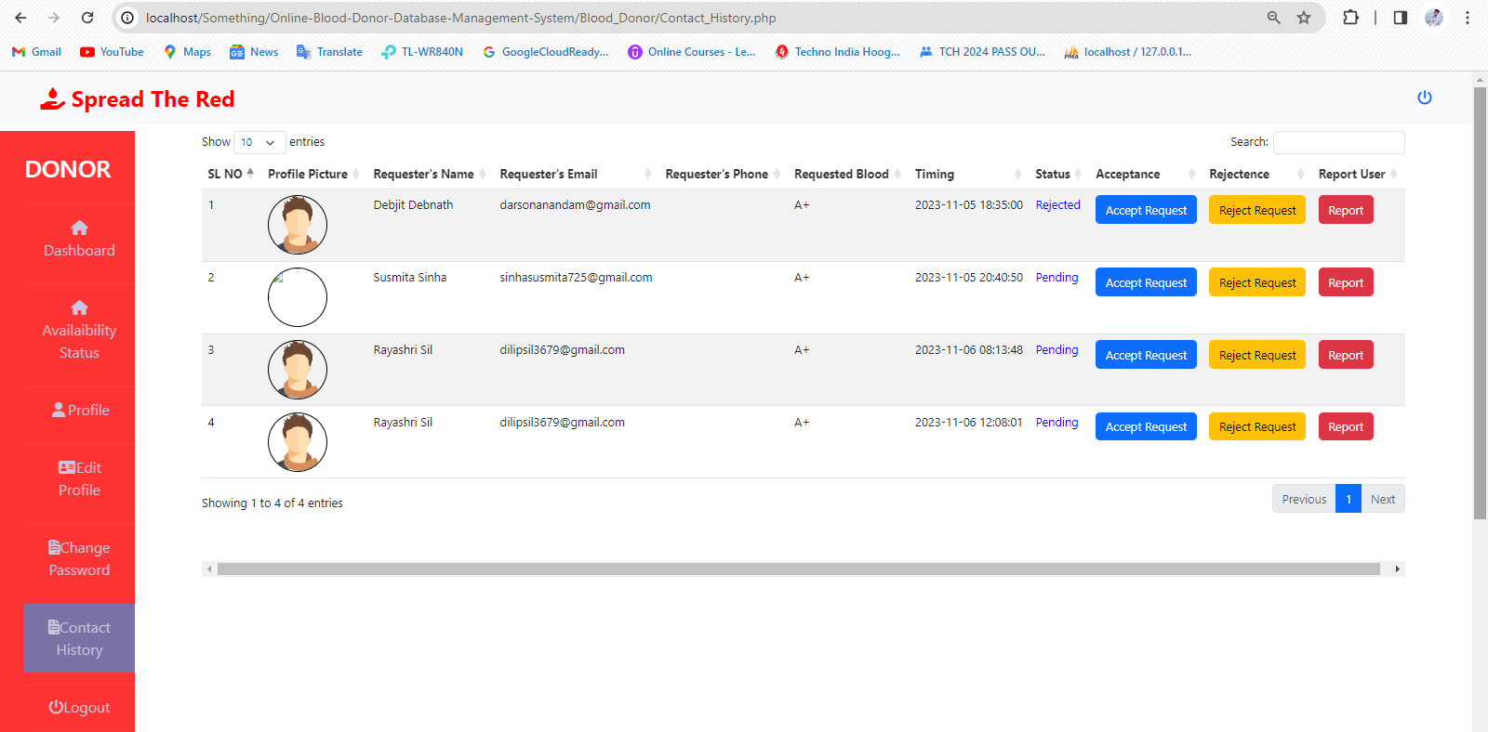

AND THE STATUS CAN BE CHANGED TO REJECTED

NOW THE PHONE NUMBER WILL BE HIDED

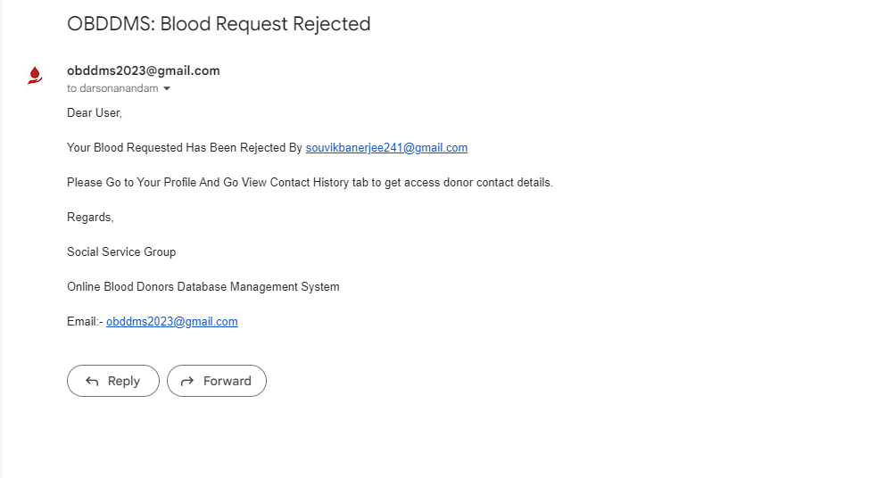

AT THE SAME TIME THIS EMAIL CAN BE SENT TO THAT REQUESTER



TO REPORT THIS BLOOD REQUESTER CLICK ON THE REPORT BUTTON

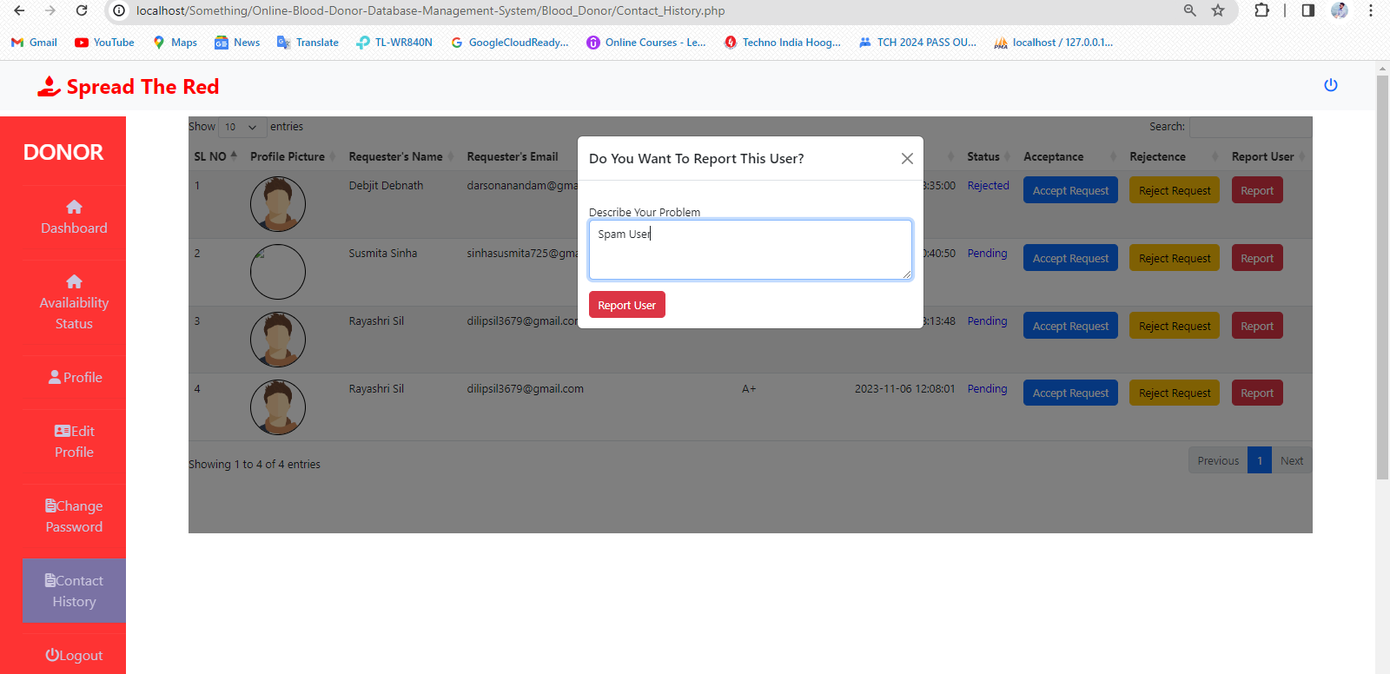

NEXT CLICK ON THIS BUTTON TO SUBMIT REPORT

FILL UP THIS FIELD

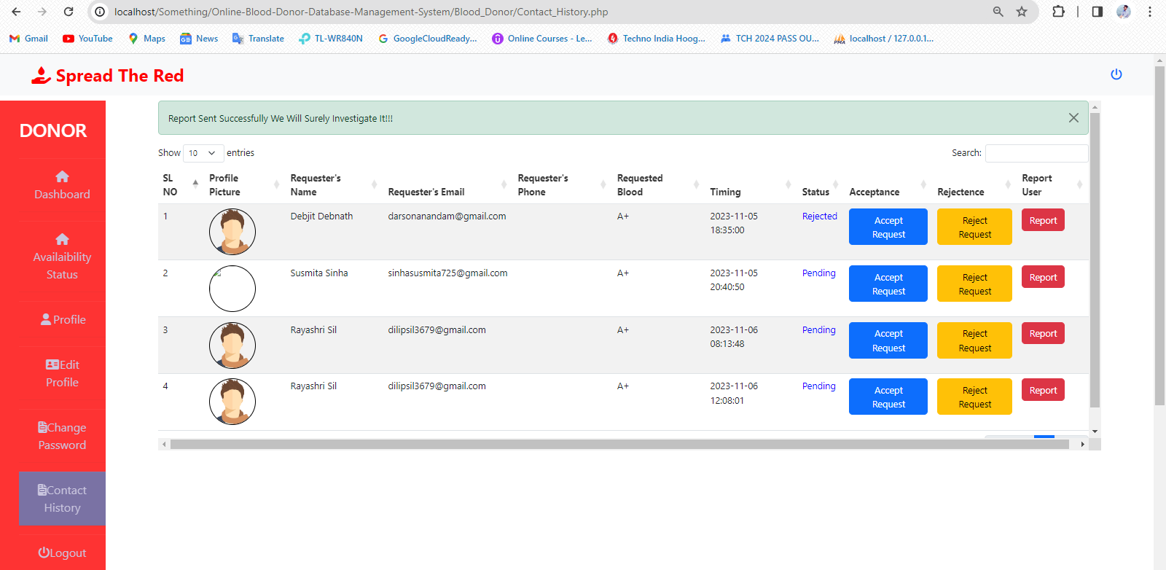

REPORT SUBMITTED SUCCESSFULLY

1. The donor can view their profile through the ‘Profile’ option.

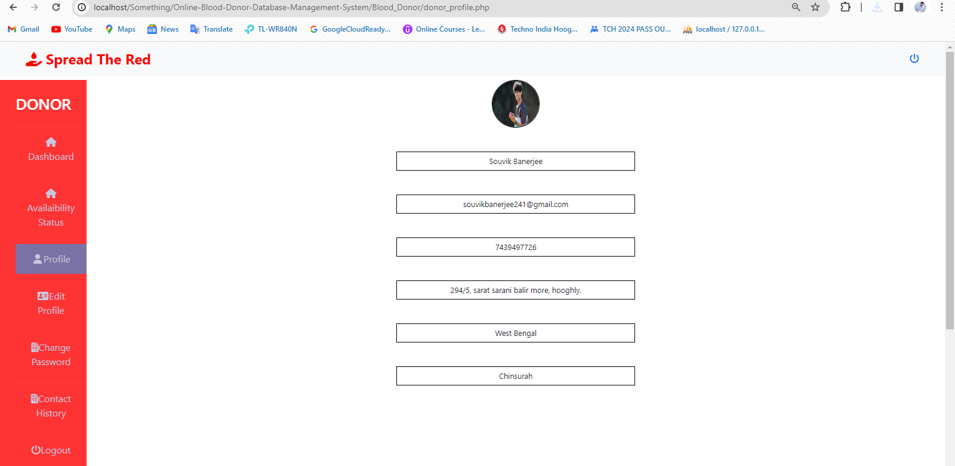

1. Donor also will be able to edit their basic account details via ‘Edit Profile’ option.

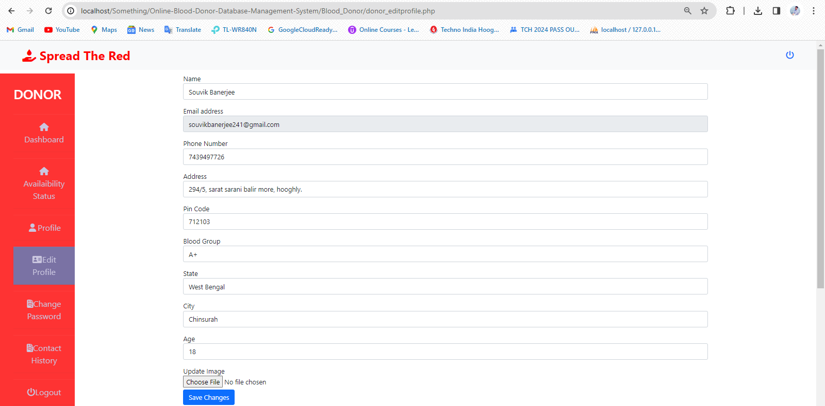

1. Any time a donor can change their password through the ‘Change Password’ option.

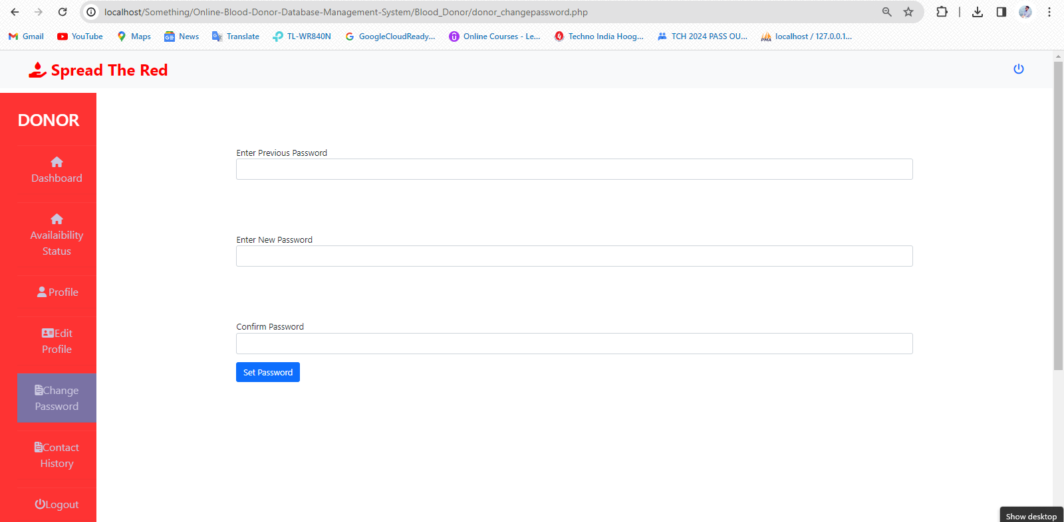

1. 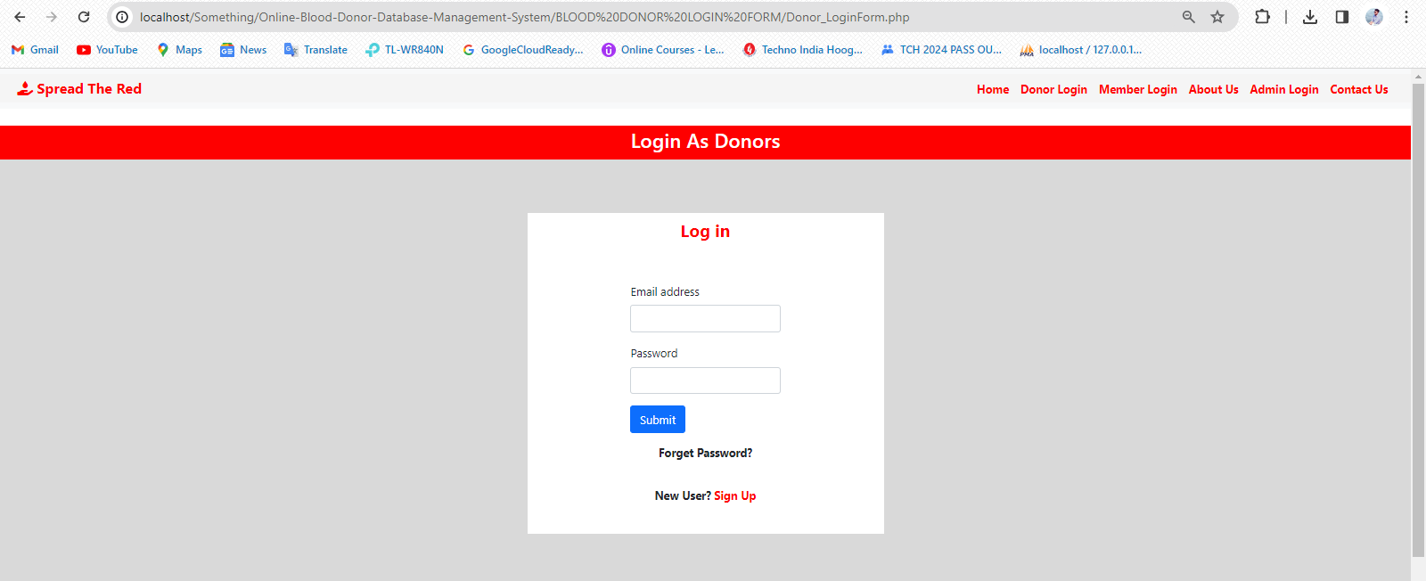Forget password instructions

CLICK HERE

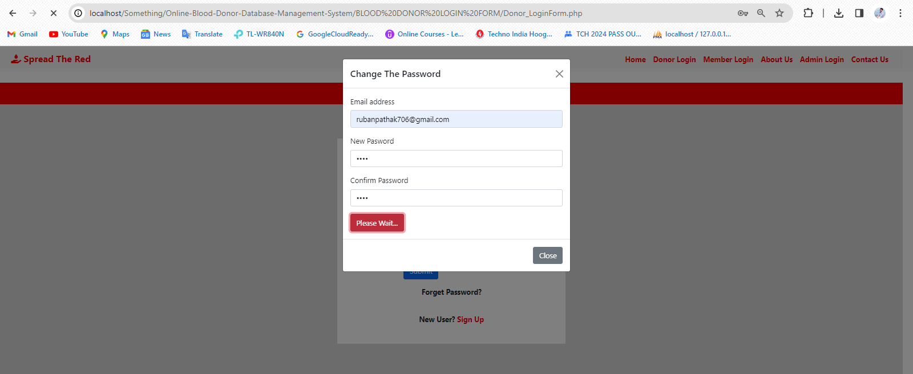

AFTER FILLING UP THE FORM CLICK HERE

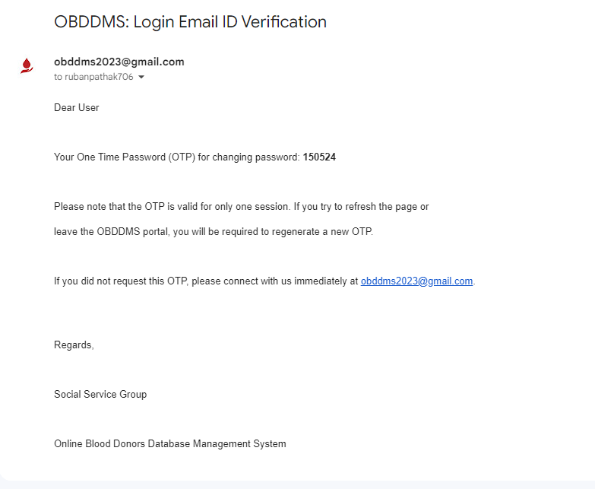

COPY THIS OTP

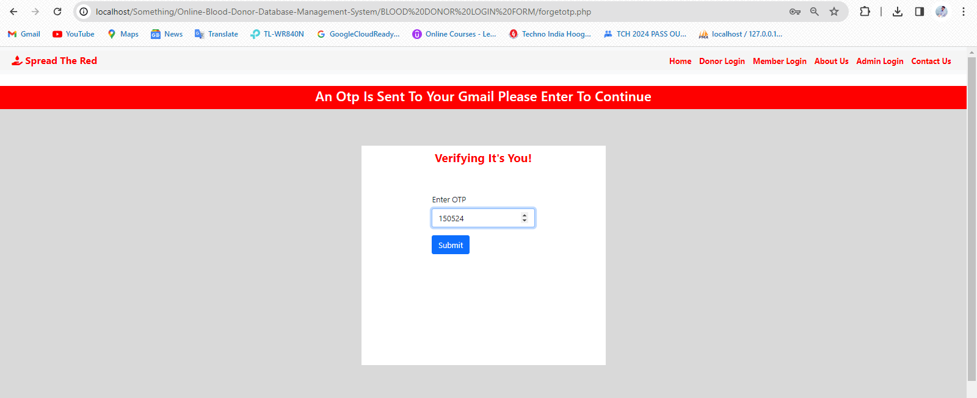

PASTE THE OTP AND SUBMIT THE OTP TO CHANGE YOUR PASSWORD